Task on CloudFront & Route 53

- Configure VPC peering in cross regions.
Create VPC Peering Connection from requester VPC and Select accept, VPC in another region.
Accept the peering request in the accepter region and update the route tables in both VPCs.
Configure security groups to allow traffic and the Test connectivity using private IPs and it will
work.
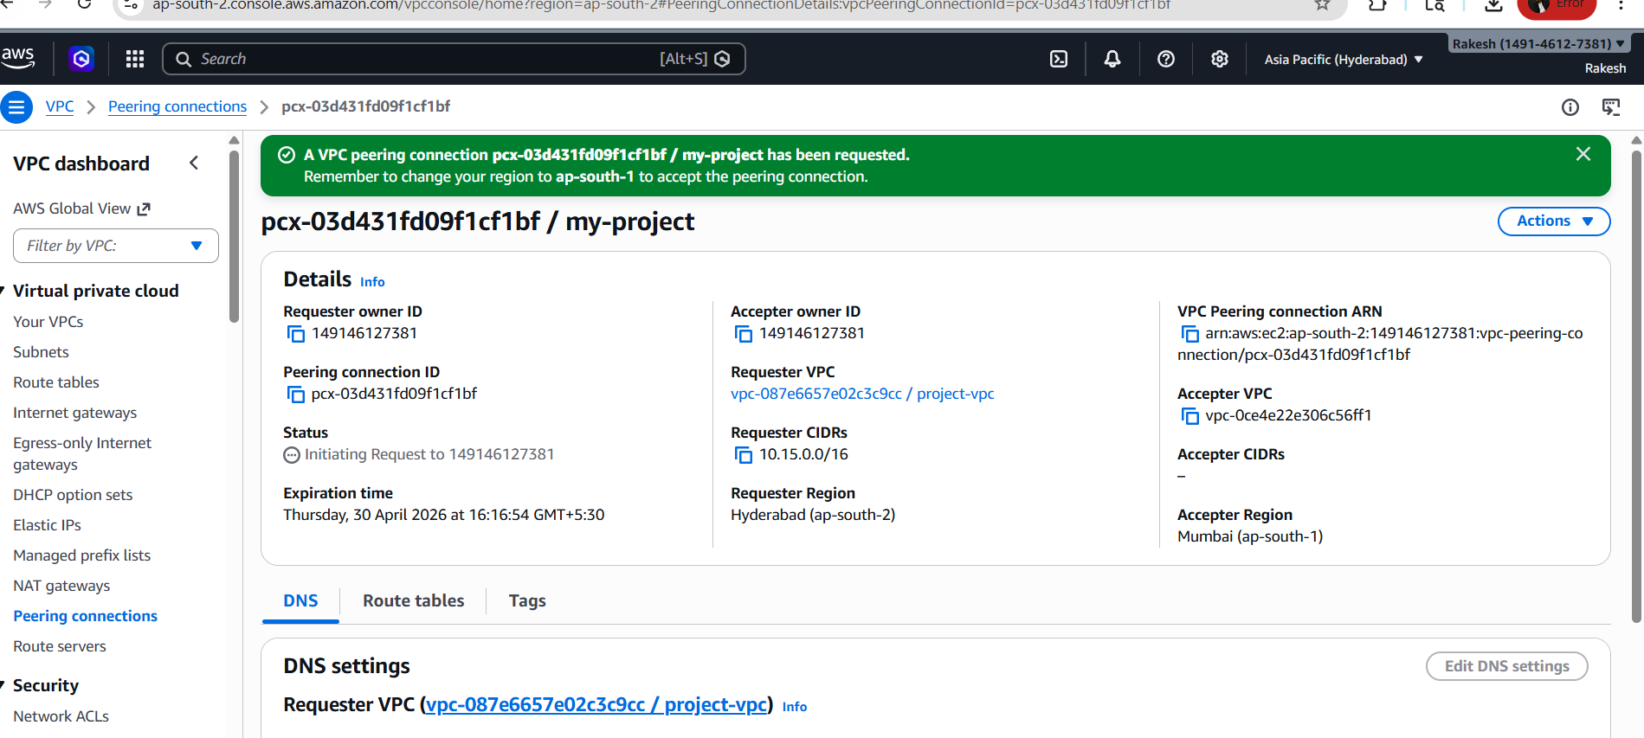
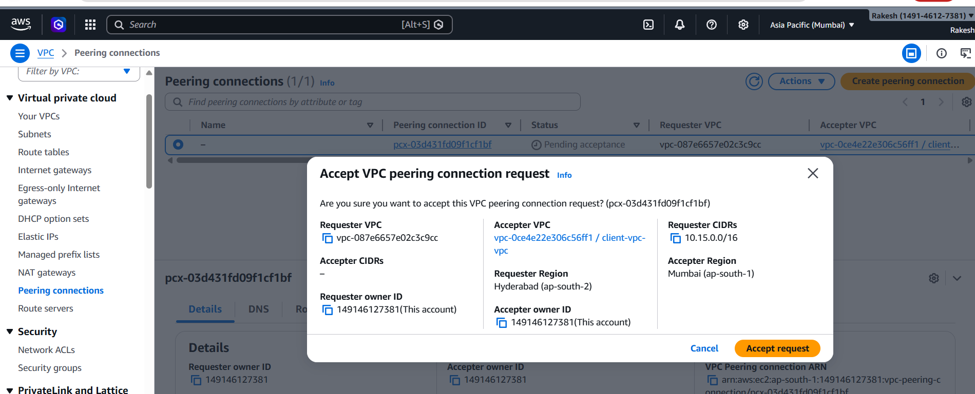

- Purchase one domain from GoDaddy.
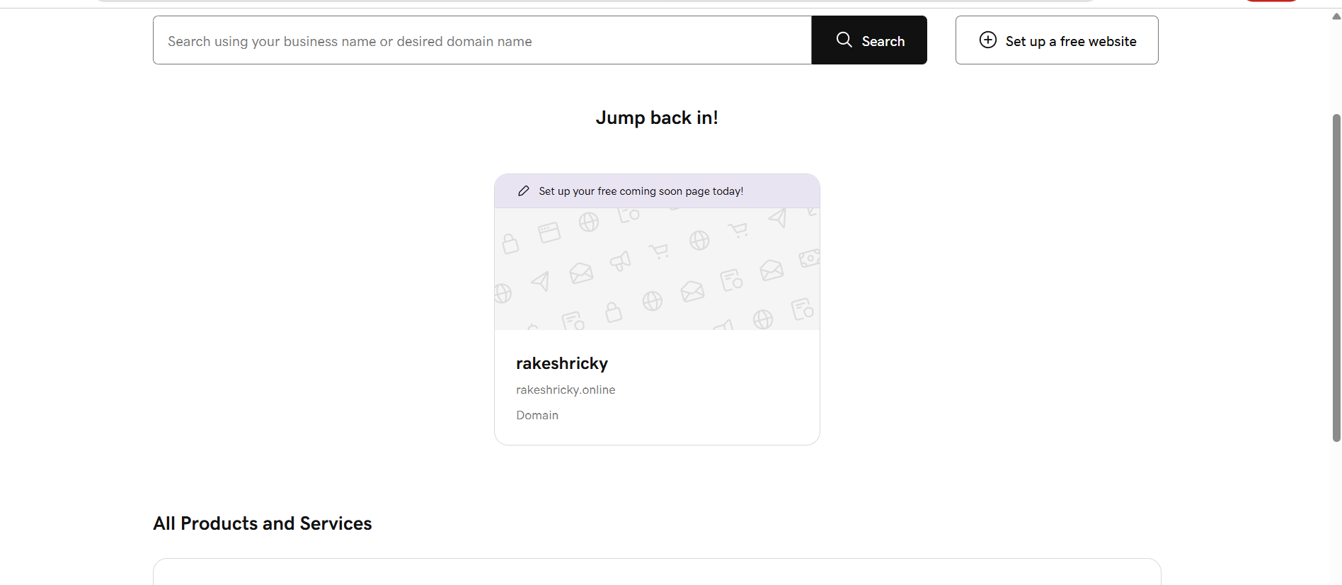

- Deploy static website in S3
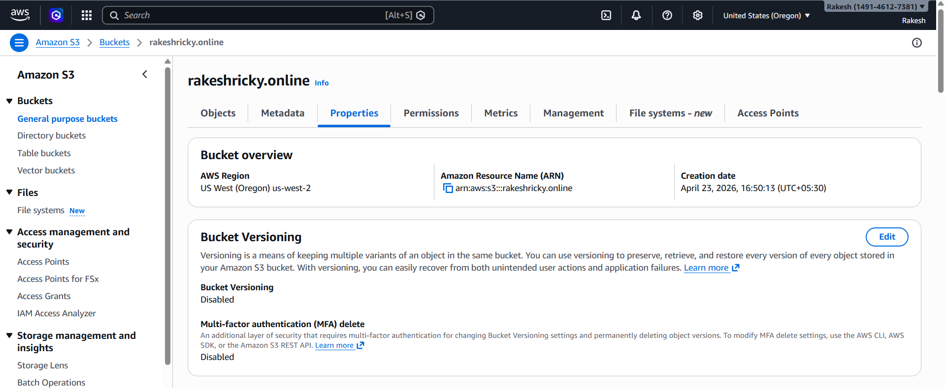
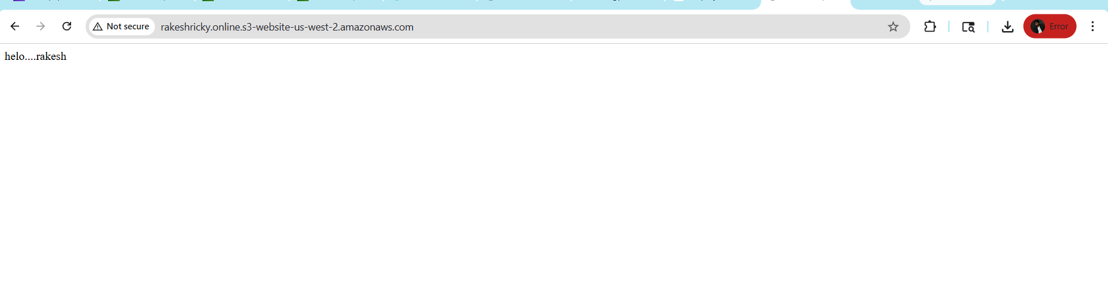.

- Create a CDN and attach one SSL certificate.
create cloud front and add domin by adding domin we want ssl certificate for that, and create one ssl certificate and attach to the cloud front
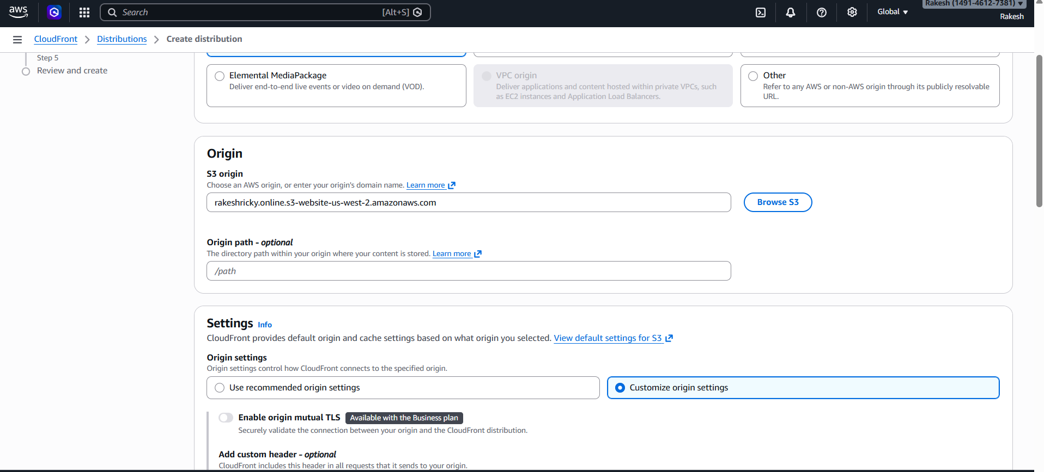
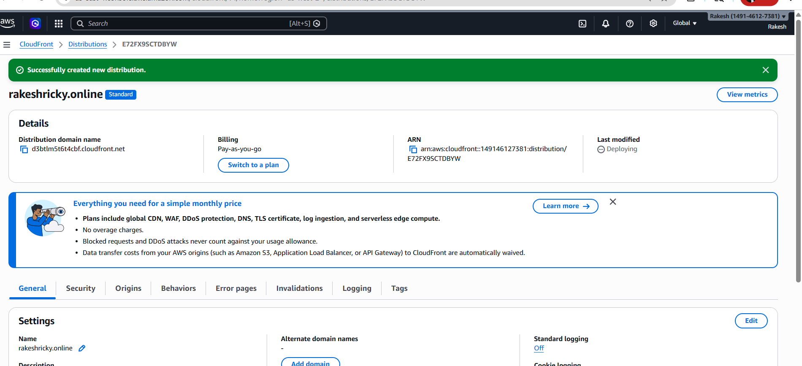
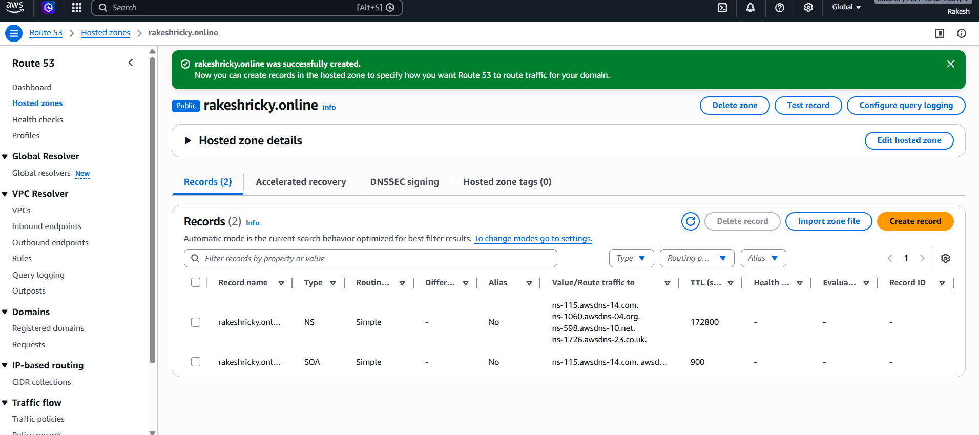

Attached name servers on go dadyy
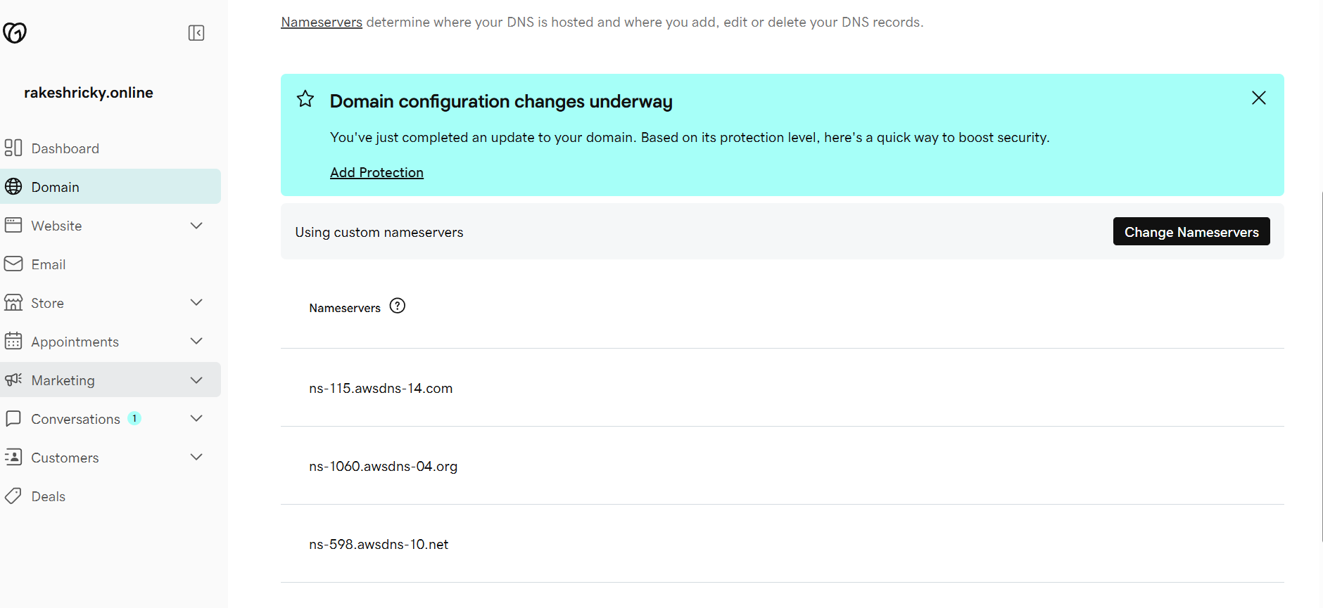

Now we are able to access our static website using cloudfront url.
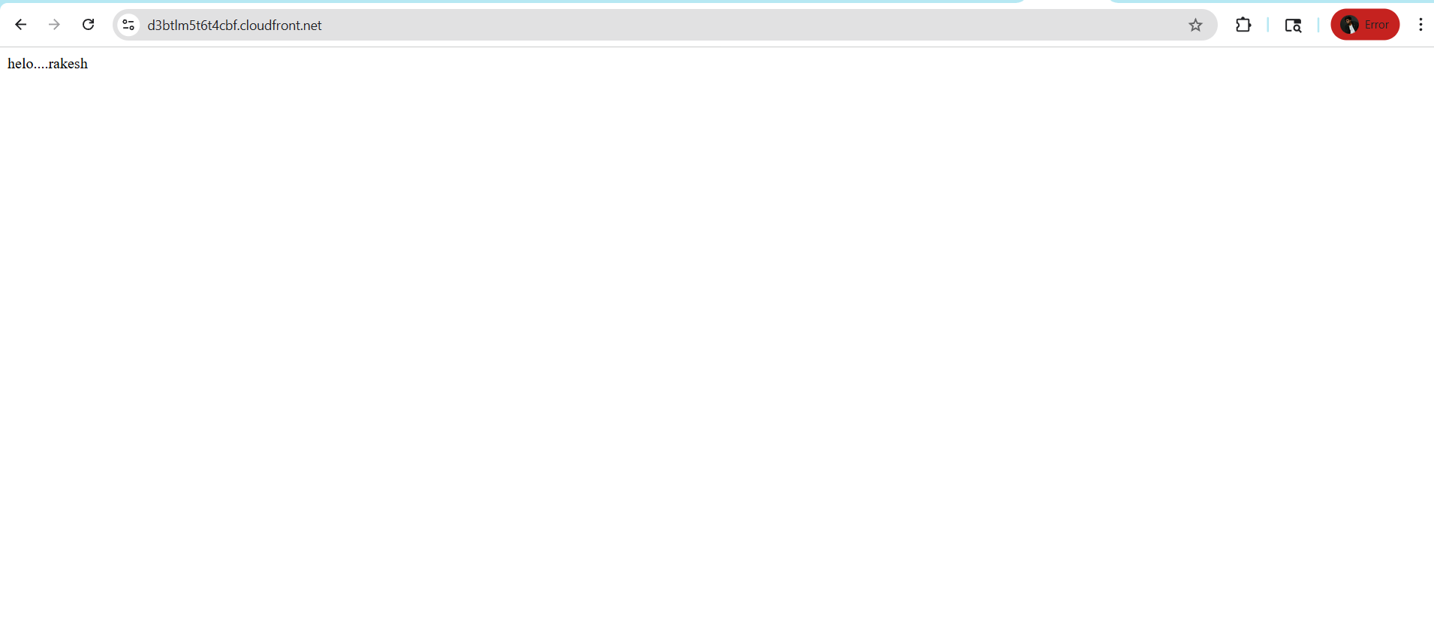

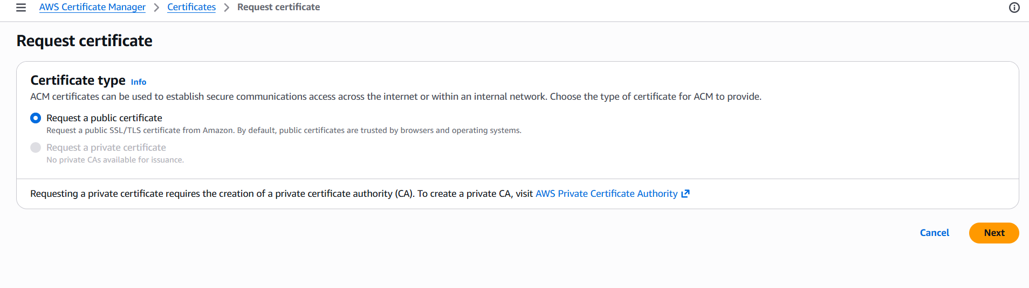
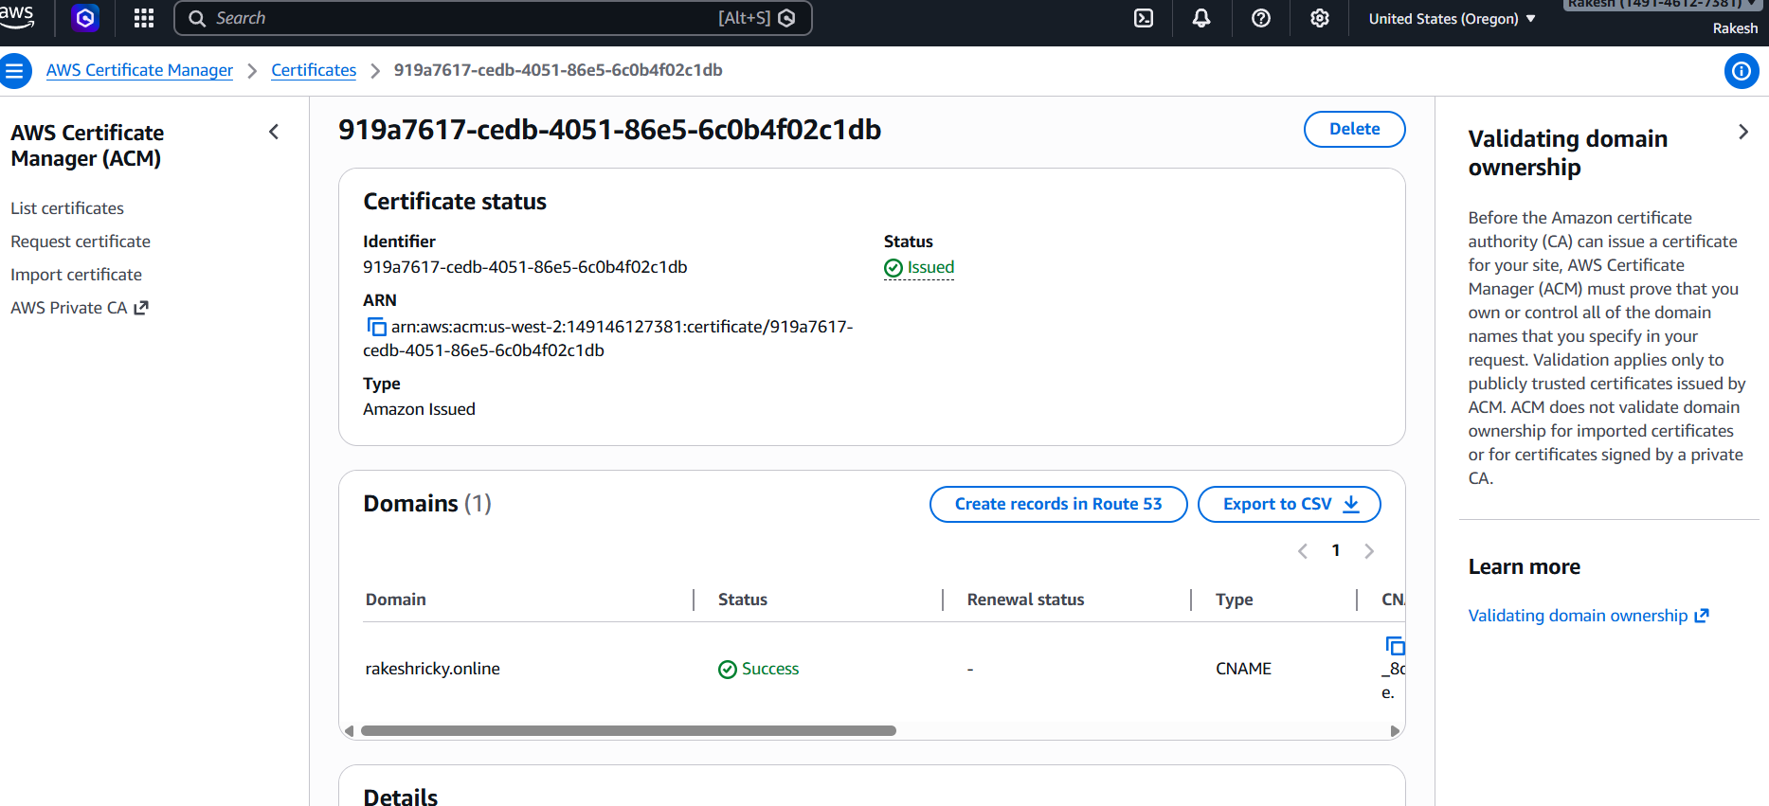

Let us now attach the certificate to the cloudfront distribution.
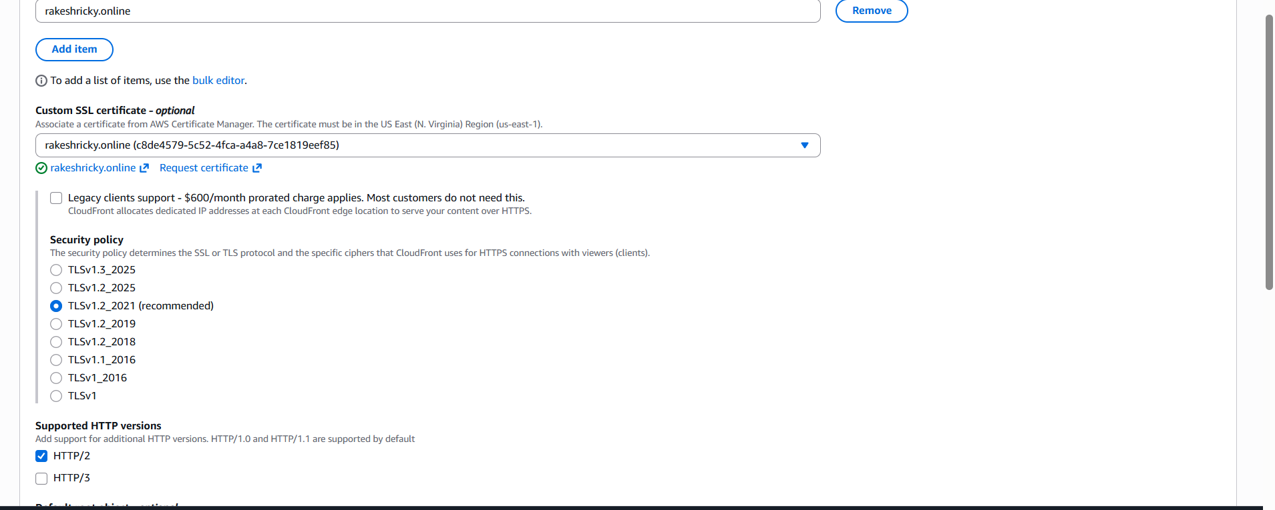
The certificate is now attached to our cloudfront dirstribution.

- Create a Route 53 hosted zone and map the domain with the CDN.
Let us now go to route 53 and create hosted zone.
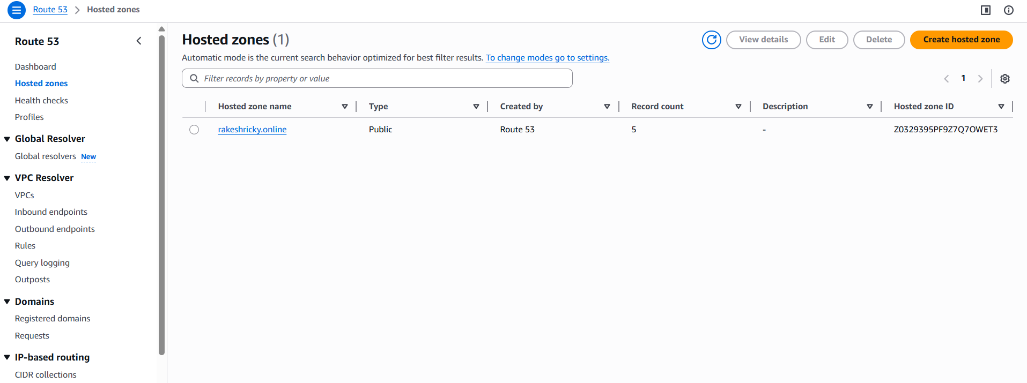

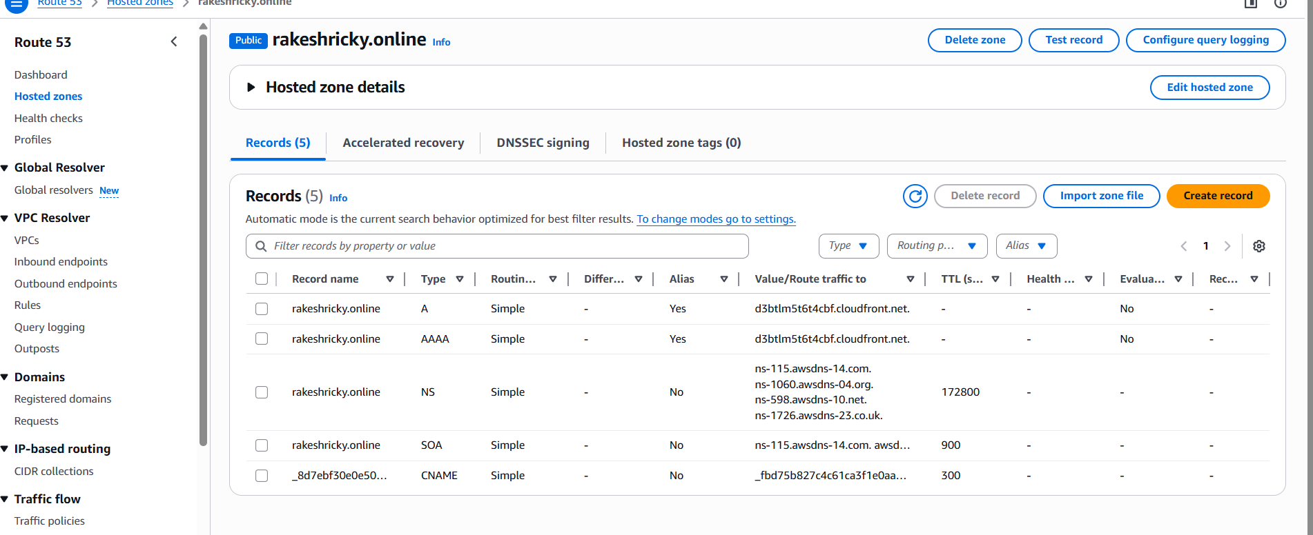

The hosted zone is now created now we need to add NS record in our domain providers DNS settings.
In GoDaddy.com go to my products.

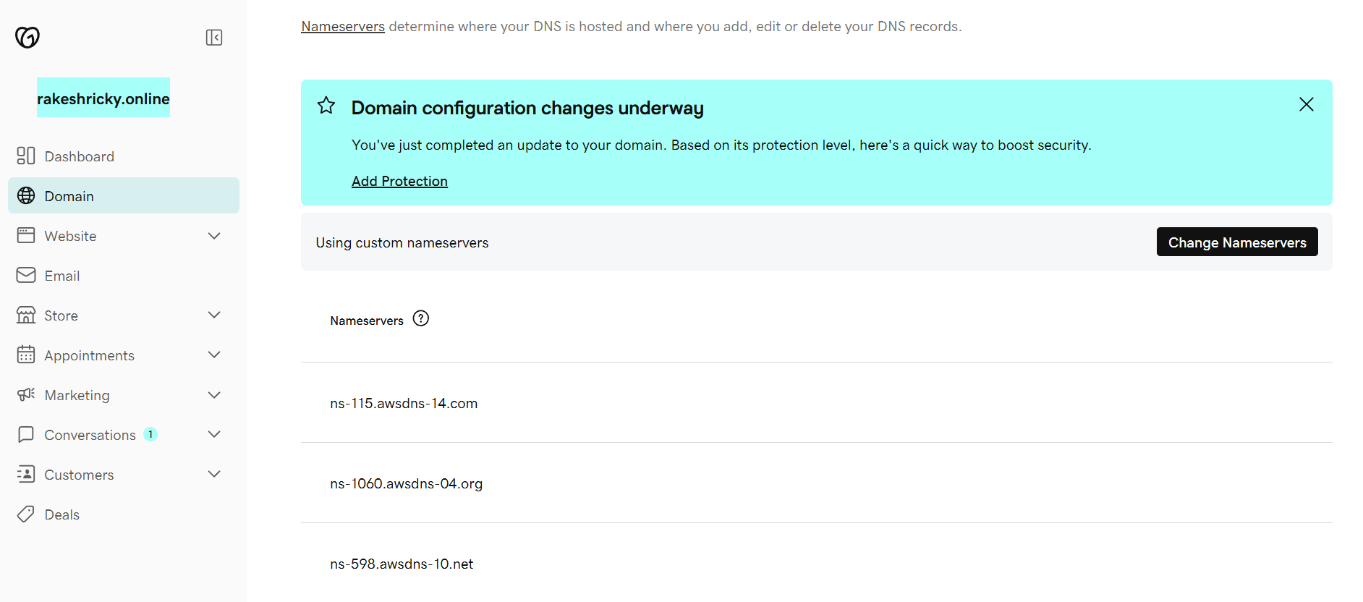

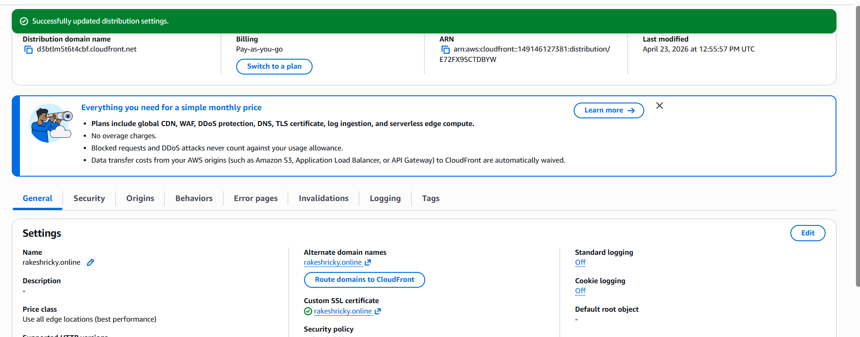

Our domain name and ssl certificate are now mapped to our cloudfront
distribution.
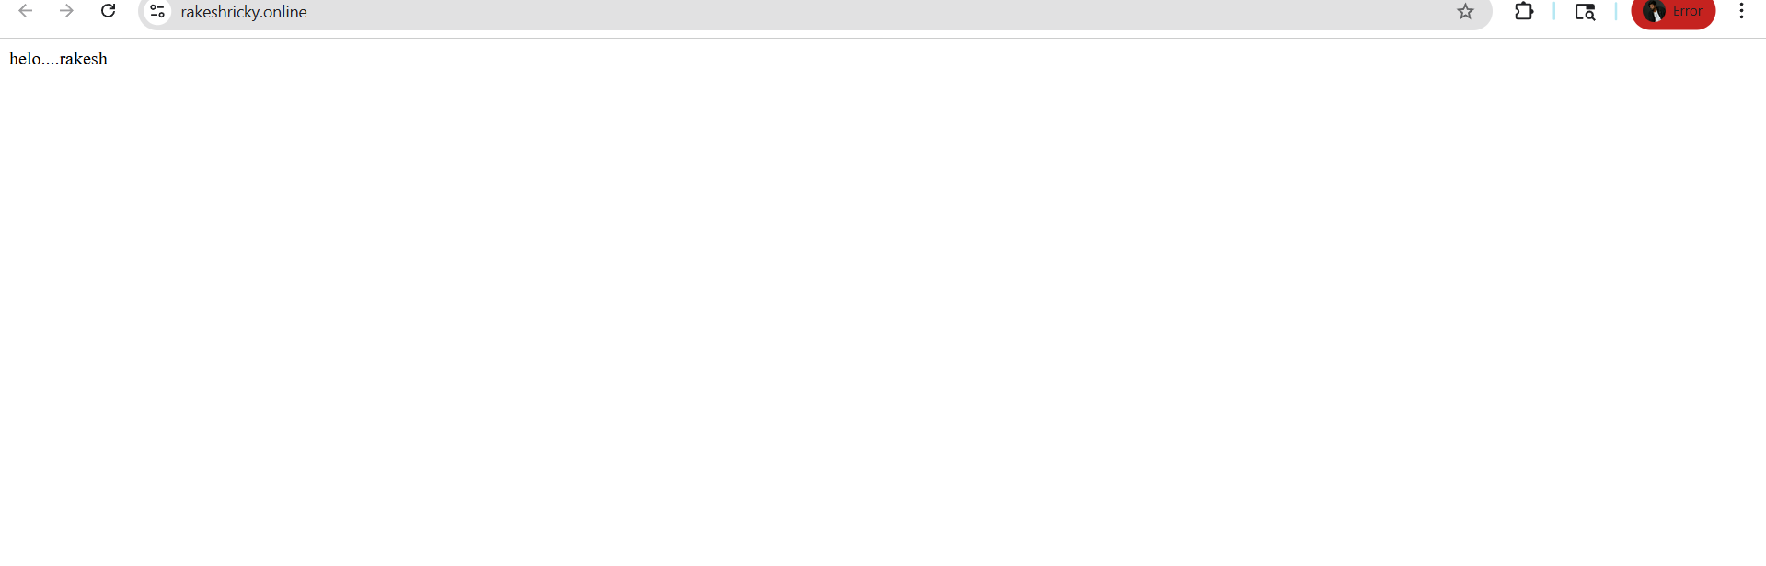 The static website is now working on our url.
- Update the index.html in the S3 bucket and ensure the updated file is accessible using the domain name.
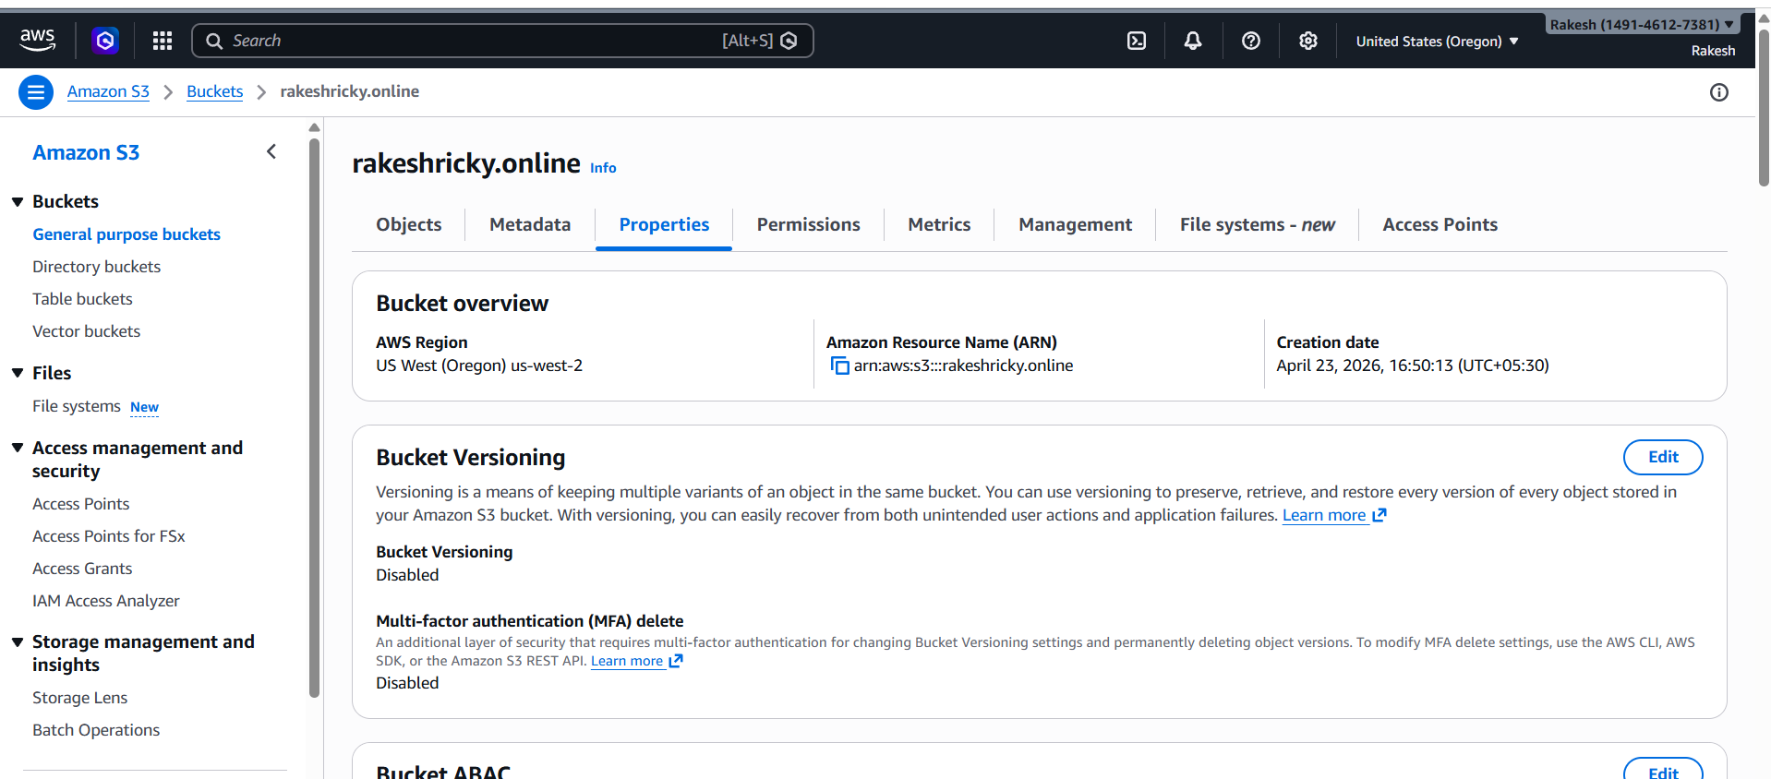
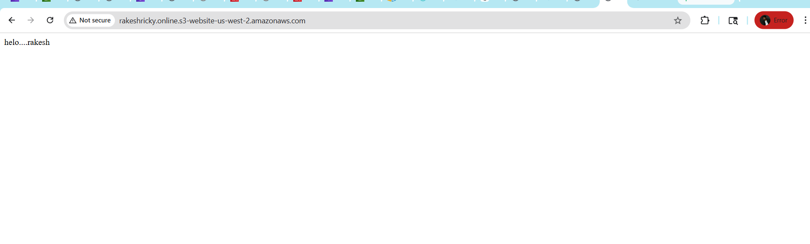
- Share the domain name in Slack to test the connectivity.
rakeshricky.online

